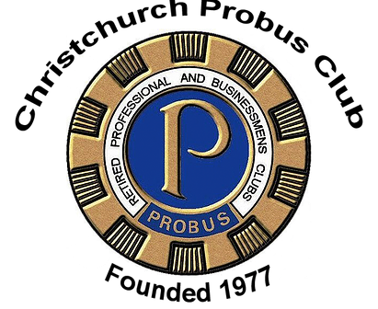

Vardy v Rooney: The Wagatha Christie Trial

Friday 20th February 2025 7.30pm.
Arrive at 7.00pm for 7.30pm start.
The cost is £14.00 per person. (No concessions)
The theatre is in Ballard School, Fernhill Lane, New Milton, BH25 5SU
which is a private school with an excellent theatre.
Please email mdowling@gmx.com if you would like to attend.
Payments to be made to our Treasurer James Robertson
Payments by BACS: Club sort code 30-92-02
Club account number 00137984
Bank account: Probus Club of Christchurch
Your payee reference – initial,surname,”soc”

Payments by cheque: Cheques should be made out to the
“Probus Club of Christchurch”. Or our Trading name of
“Christchurch Probus Club”.

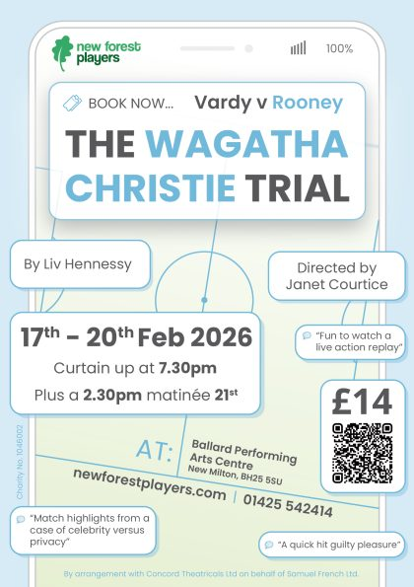
What's it about?
Edited from seven sensational days of High Court transcripts, witness the case of Rebekah Vardy v Coleen Rooney unfold in their own words.
A story stranger than fiction that blurs the boundaries of tabloid scoop, court case and soap opera, this trial explores privacy and celebrity in modern Britain whilst asking who is Davy Jones and where exactly is his locker?
While the country was captivated, only a handful of people witnessed what happened behind closed doors. Now you can too.

The Cast & Crew
CAST
Rebekah Vardy – Lou Mellanie Hutchings
Coleen Rooney – Rachel Mackay
David Sherborne (Coleen’s barrister) – Paul Berry
Hugh Tomlinson, QC (Rebekah’s barrister) – Peter Cutler
Mrs. Justice Steyn – Wendy Beaumont
Jackie (Pundit 1 also playing Caroline Watt) – Courtney Fereday
Jem (Pundit 2, also playing Harpeet Robertson) – Tina Ward
CREW
TBA

